

**Tutorial No. 1**

**Title: Planning a web site by creating layout for the webpages**

# Batch:B2 Roll No.: 16010421119 Tutorial No.: 1

**Aim: To understand concept of planning a website**

**Resources needed: Internet**

**Theory:**

**Following Steps can be followed for layout designing of a website. Site Map**

Draft a sitemap that meets the description provided below.

Show the hierarchy and relationships between pages starting with the index page at the top. Create a digital copy of your sitemap using a word editor or visual editing programs like a mind mapping application or Visio. Be sure to save your document in a format that is widely supported and has a high enough resolution to be legible, like jpg, HTML, or pdf. Unless you are sure the parties who will receive these types of documents are using the same program you are, you should avoid proprietary file types.

# Site Wireframe

Design two or three basic layouts for your site, or the alternative example described in the Site Map assignment, including a front page and typical content page for each. Include depictions of where certain pieces of content are expected to be located with their approximate size. Keep in mind a wireframe is about content elements and location, not a specific style, color, or actual content.

# Storyboarding

Create a storyboard of a possible user experience your site. You might follow the process of signing in, creating an account, searching for a product, or navigating to a particular piece of content. Find an example that involves at least 4 steps. Create a mockup for each step that includes color and fake content, describing on each panel what action the user will follow to move to the next step.

# Activity:

1. Choose topic for website
2. Describe content of website in detail
3. Prepare layout of web site

# Topic of Web site:

Fitness Blog - Fitera

**Content of Web site:**

* **Blogs:** No longer just for writing about your feelings or the day, blogs are an important component of a website’s content marketing strategy. Blog posts are often short—around 750 words—and are designed to inform, entertain, and delight your readers.
* **Case Studies:** Brands can use case studies to illustrate their value proposition by writing about how their product or service helped a customer or client. Case studies are specific to a brand and should provide in-depth details or data around results.
* **Checklists:** Often downloadable, checklists are fantastic pieces of lead generation content, content that aims to attract potential new clients. Templates should offer concise, actionable steps for readers. If the content is downloadable, companies should also ensure their branding is present on the piece.
* **Ebooks:** Another type of lead generation content, ebooks are long-form writing packaged into a book, generally in PDF format. Ebooks are an opportunity for brands to provide thought leadership on a given topic, strengthening their authority on a given topic.
* **Website Copy:** Content that appears on pages of your website like a homepage, landing page, about page, or FAQ. Copy on your website should explain your brand, sell your product or service and lead readers throughout your site.
* **White Papers:** Shorter than ebooks, these pieces of content generally focus on one specific topic or problem and offer solutions or data to solve the issue. White papers are another excellent lead generation tactic.

**Layout of Web site:**

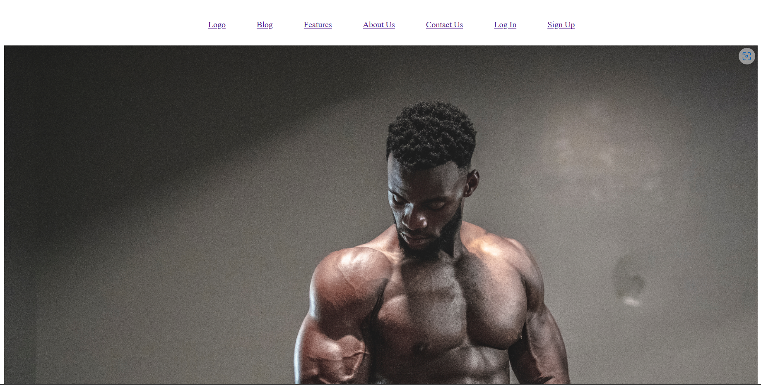

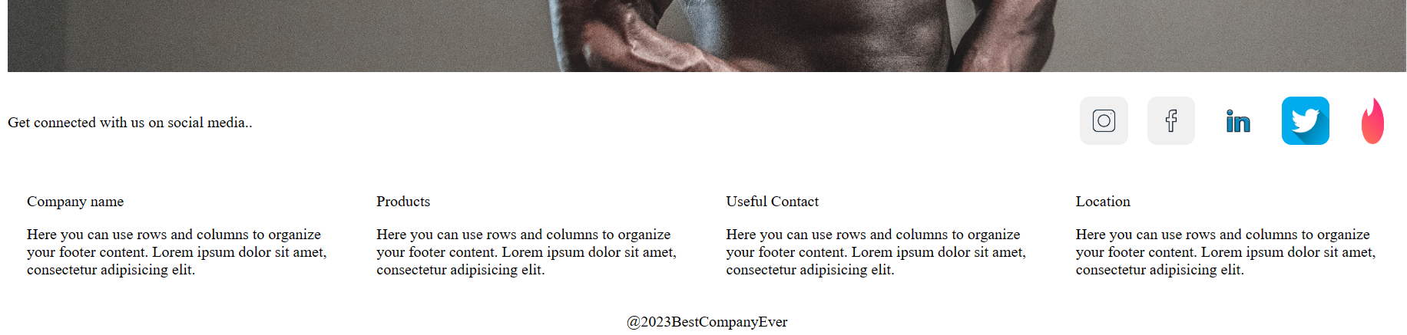

**Outcome:**

**CO1: Comprehend basics of web technologies**

**Conclusion:**

**We have learnt about the basics of the creating a layout of the website along with content and topic**

**References:**

* 1. https://eng.libretexts.org/Bookshelves/Computer_Science/Book%3A_Web_Developm

ent_and_Programming_(Mendez)/01%3A_Web_Development/1.E%3A_Web_Devel

opment_(Exercises)

* 1. More references to be added by student as required.